Operational Concept Description (OCD)

LINGGGO
Team 3

Chicheng Ren – Software Architect
Dahai Li – Quality Focal Point
Dashun Wen – Life Cycle Planner
Kraingkrai Bumroungruksa –Feasibility Analyst
Siming Ye – Operational Concept Engineer
Shiqi Wei – Prototyper
Yiting Xiao – Project Manager

11/29/2015

Version History
Date | Author | Version | Changes made | Rationale
10/10/15 | SY | 1.0 | - Original template for use with LINGGGO v1.0 | - Initial draft for use with LINGGGO v1.0
10/18/15 | CCR, YX | 1.1 | - Content quality verify | - Content verify
11/29/15 | SY | 1.2 | - Update business work flow diagram | - Diagram update

Table of Contents
Operational Concept Description (OCD) i
Version History ii
Table of Contents iii
Table of Tables iv
Table of Figures v
1. Introduction 1
1.1 Purpose of the OCD 1
1.2 Status of the OCD 1
2. Shared Vision 2
2.1 Benefits Chain 3
2.2 System Capability Description 4
2.3 System Boundary and Environment 5
3. System Transformation 6
3.1 Information on Current System 6
3.2 System Objectives, Constraints and Priorities 6
3.3 Proposed New Operational Concept 8
3.4 Organizational and Operational Implications 9

Table of Tables
Table 1: The Program Model 2
Table 2: Level of Service Goals 6
Table 3: Relation to Current System 7

Table of Figures
Figure 1: Benefits Chain Diagram of LINGGGO 3
Figure 2: System Boundary and Environment Diagram of LINGGGO 5
Figure 3: Element Relationship Diagram of LINGGGO 8
Figure 4: Business Workflow Diagram of LINGGGO 9
Figure 5: Business Workflow Diagram of LINGGGO 10

Introduction

Purpose of the OCD
This document provides, in detail, the shared visions and goals of the stakeholders of LINGGGO.

Status of the OCD
The status of the OCD is currently at the on-going in the bug fixing phase. The scope of the LINGGGO has been evaluated to meet the clients’ core requirements, and the prototype has been built so that development team can design and build the system with feedback from the client.

Shared Vision
Table 1: The Program Model
Assumptions
- People desire to learn language
- People desire to learn from a native people
- People like to teach
- People are going to go online to match language exchangers

Stakeholders | Initiatives | Value Propositions | Beneficiaries
- Language learners  - Developers (LINGGGO team members)  - Maintainers (Wesley plays the role now, and clients will hire others when our team is not in charge of the project)  - Testers (LINGGGO team members)  - Clients (Zsuzsa Londe and Ajay Rai) | - Build the new system  - Learn languages  - Maintain the system | - Language learners find each other to practice language  - Increasing learning opportunities  - Increase chances for language learners to meet native speakers  - Increase awareness of other culture through individual meetings and conversations  - Save time looking for language learners | - Language learners

Benefits Chain

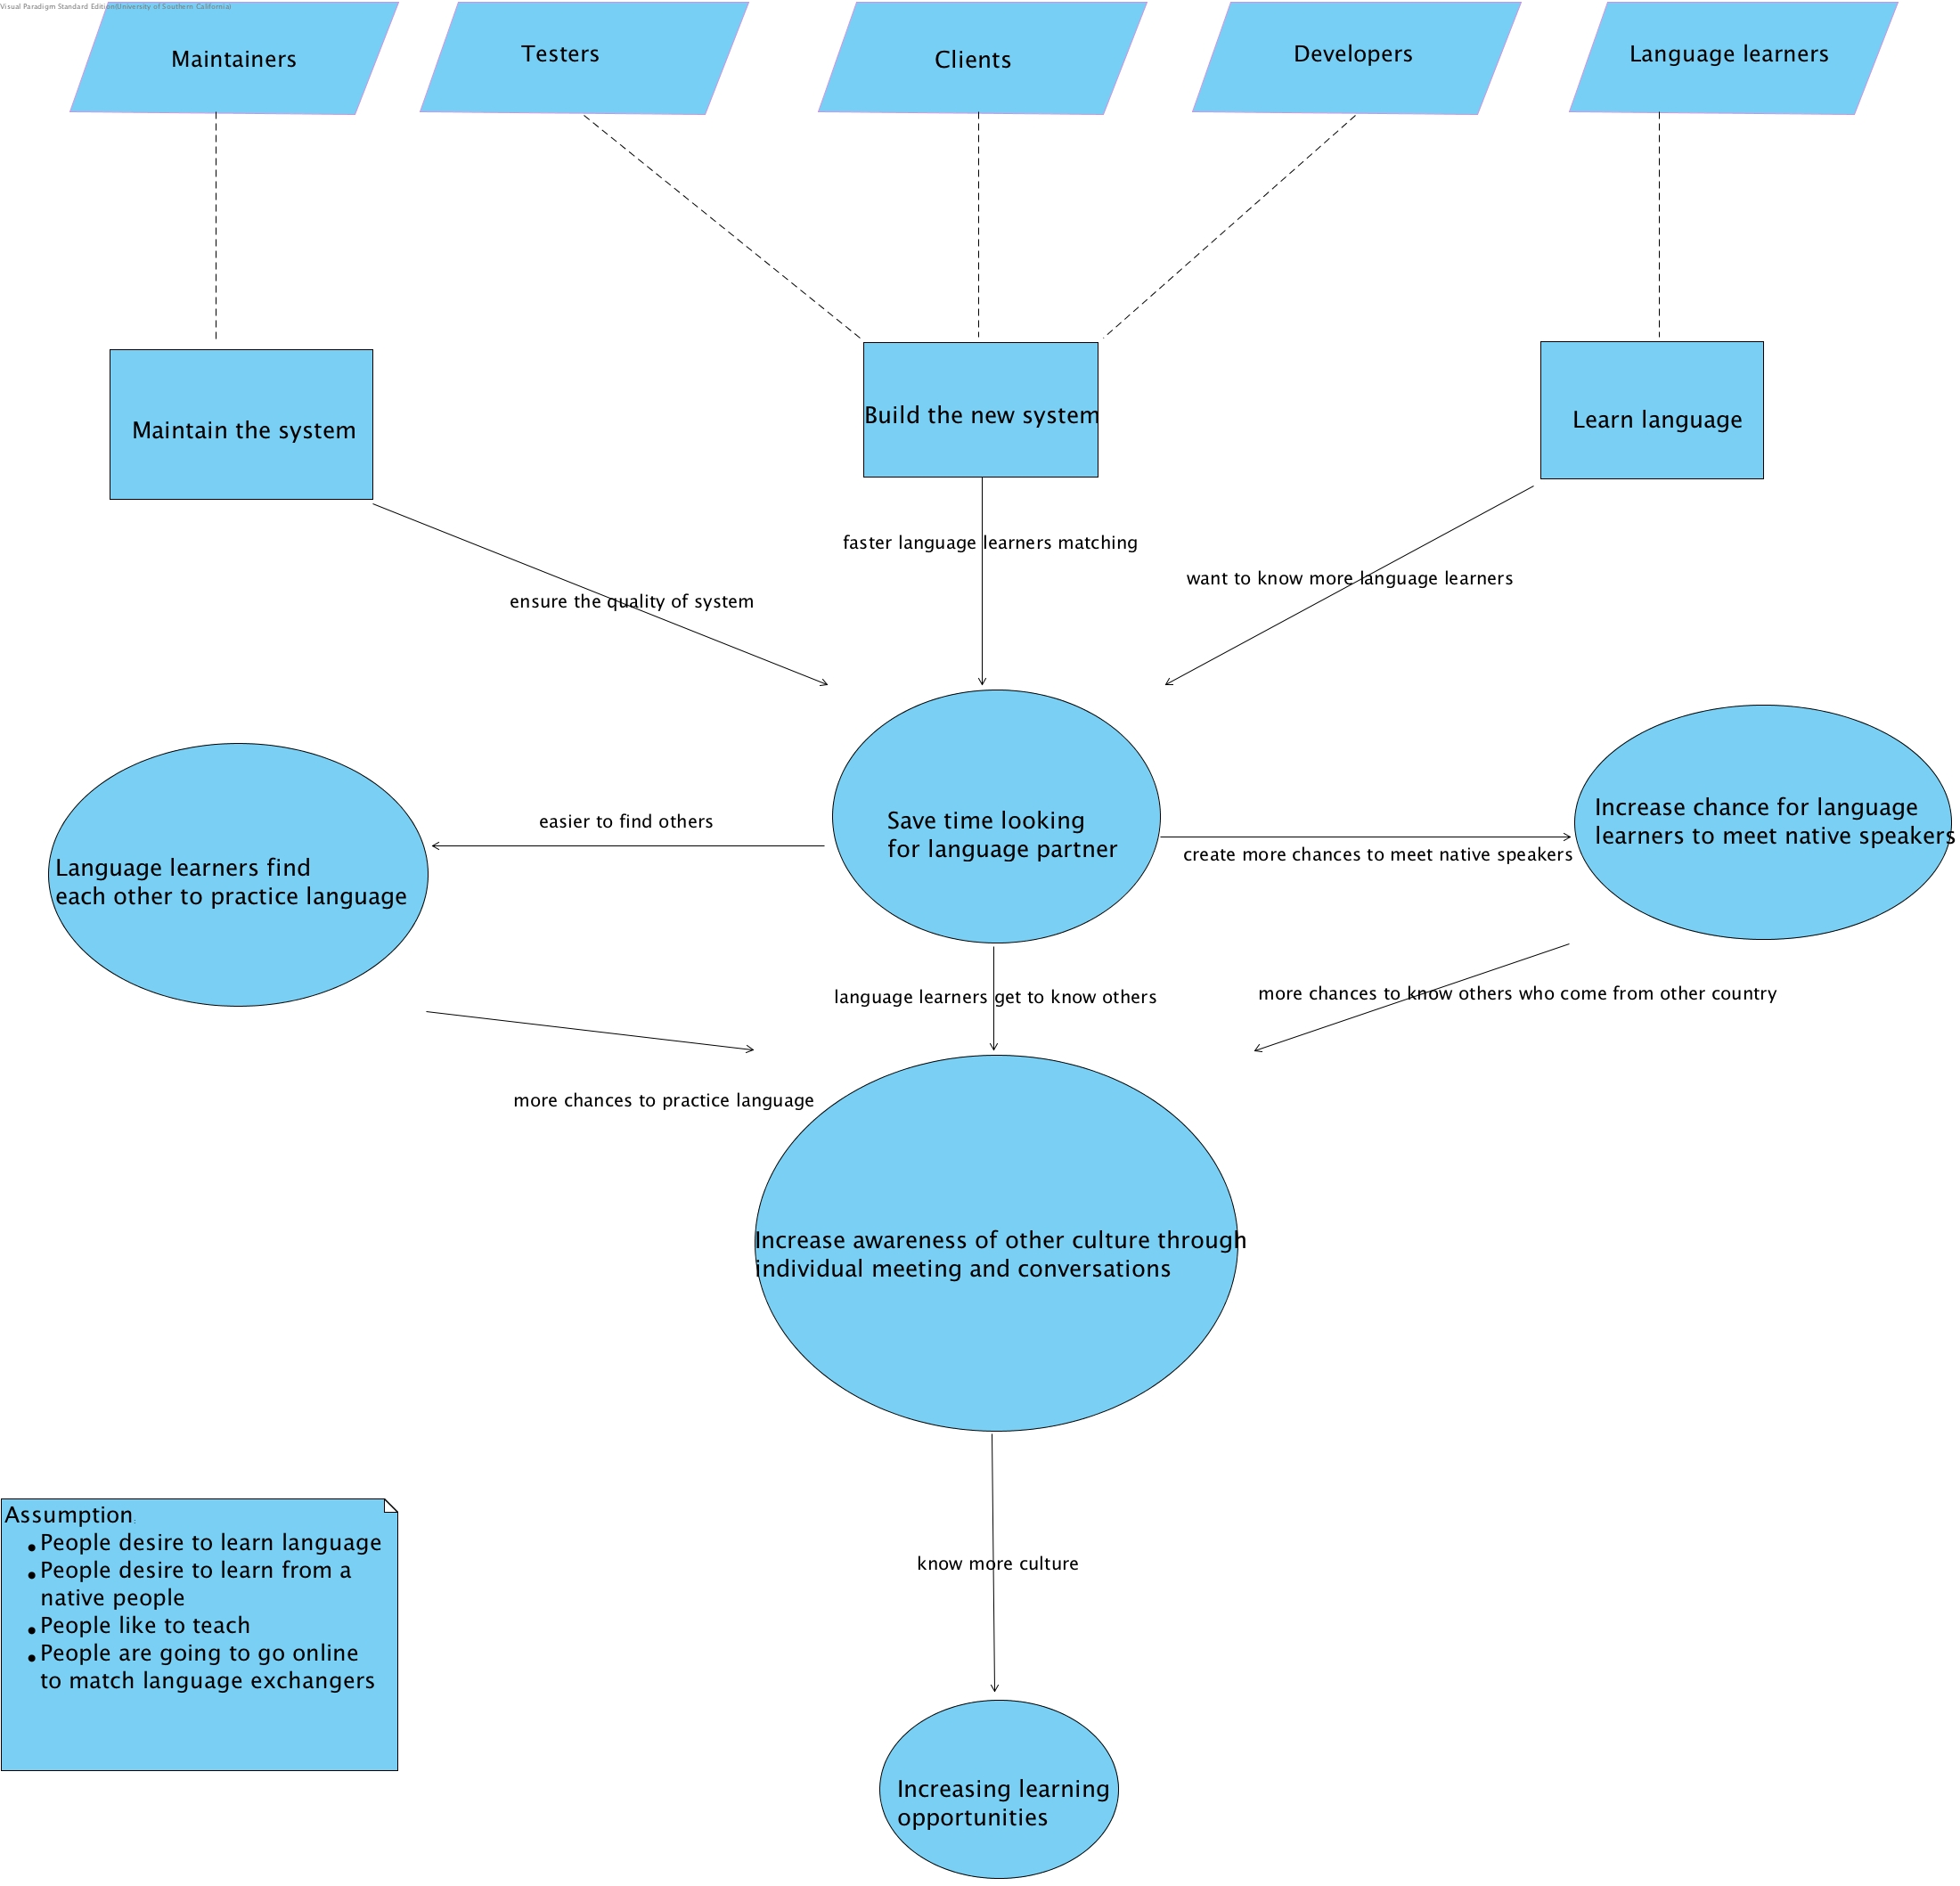
Figure 1: Benefits Chain Diagram of LINGGGO

System Capability Description
- LINGGGO is a social collaboration website helping people find language exchangers.
- The main target customers are language learners who are over 18 years old.
- Language learners may have a difficult time finding practicing partners, and there are seldom systems/platforms that offer the opportunity for language learners to search for fellow language learners. LINGGGO provides a space for language learners to find and interact with each other.
- Language learners want to find other language learners, and this is why they will choose to use LINGGGO.
- For now, italki; livemocha; and duolingo are our competitors.
- Our LINGGGO system offers language learners a match feature. Language learners can match with other language leaners; LINGGGO also offers an inbox messaging feature which allows language learners to send messages to each other.
- LINGGGO has a user registration module for Language Learners to create and manage their accounts

System Boundary and Environment
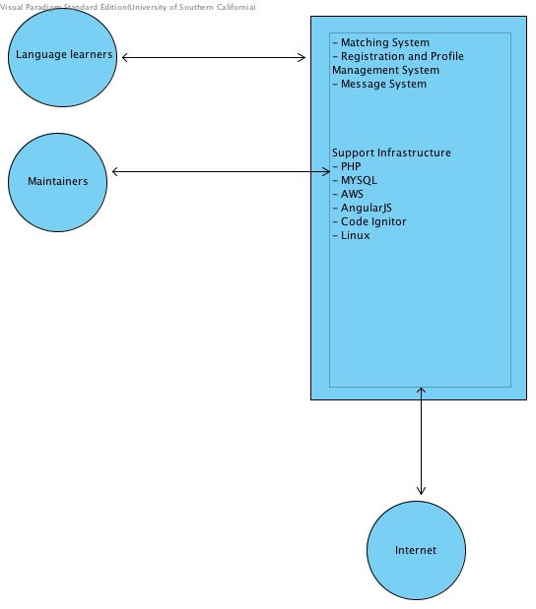
Figure 2: System Boundary and Environment Diagram of LINGGGO

System Transformation

Information on Current System

Infrastructure
Hardware: AWS
Software: PHP Code Igniter, Angular JS, Slack, Jira, Github, Gmail, Winbook

Artifacts
- Win-Win agreements: it describes the win-win conditions that our team discussed with clients.
- Project plan: this describes our schedule for the whole development lifecycle.
- Project risk and defect: this shows the top risks and defects we come up with.
- Client interaction report: this describes the achievement our team made with clients.

Current Business Workflow
Since we build our system from scratch, so we do not have a current business work flow.

System Objectives, Constraints and Priorities

Capability Goals
Capability Goals | Priority Level
Match language learner | High
Register accounts and manage profile | High
Send/Receive messages | High

Level of Service Goals
Table 2: Level of Service Goals
Level of Service Goals | Priority Level | Referred WinWin Agreements
The language learner can receive the Match result in 3 seconds | High | As a language learner, I can use this system to find other learners learner, so that I can practice or teach a language
The language learner can Register accounts in two 2 after filling all the fields correctly and update of profile management in 3 seconds | High | As a language learner, I can register an account on the website and modify my privacy policy so that I can avoid malicious usage of my personal info.
The language learner can Send/Receive messages within 3 seconds | High | As a language learner, I can use this system to communicate with a native speaker, where I can get to know more about their culture.

Organizational Goals
OG-1: Increase language proficiency via practicing language with others
OG-2: Increase learning opportunities via language matching
OG-3: Increase chance for language learners to meet native speakers via language matching
OG-4: Increase awareness of other culture via individual meeting and conversations

Constraints
CO-1: We must make budget as low as possible

Relation to Current System
Table 3: Relation to Current System
Capabilities | Current System | New System
Roles and Responsibilities | N/A | N/A
User Interactions | N/A | N/A
Infrastructure | N/A | N/A
Stakeholder Essentials and Amenities | N/A | N/A
Future Capabilities | N/A | N/A

Proposed New Operational Concept

Element Relationship Diagram
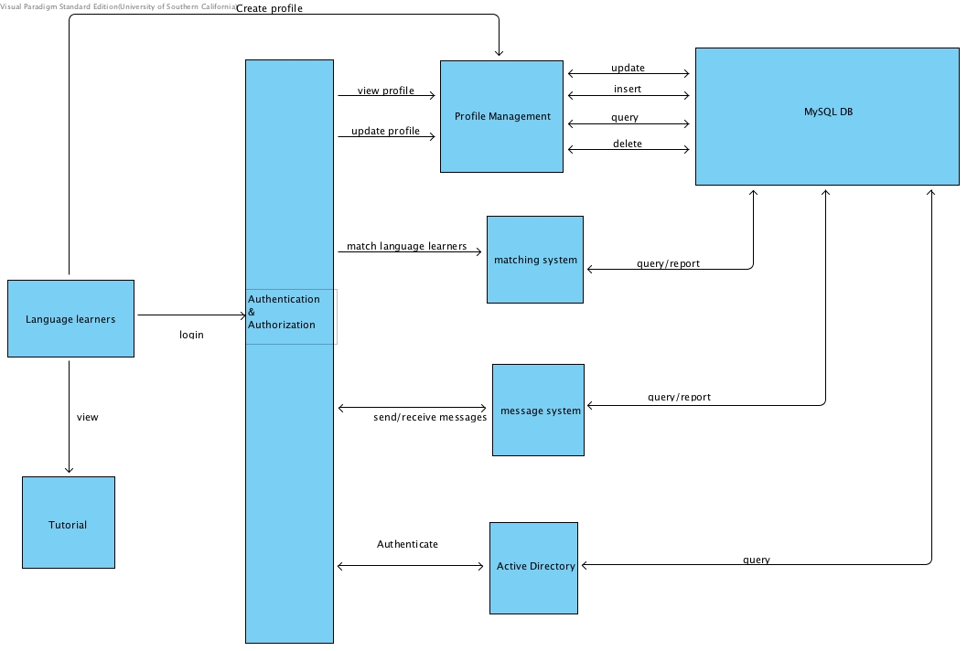
Figure 3: Element Relationship Diagram of LINGGGO

Business Workflows

Figure 4: Business Workflow Diagram of LINGGGO
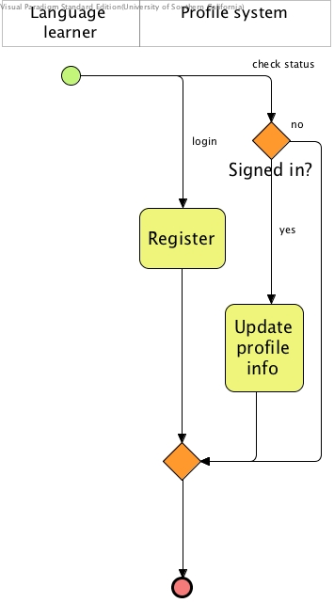
Figure 5: Business Workflow Diagram of LINGGGO
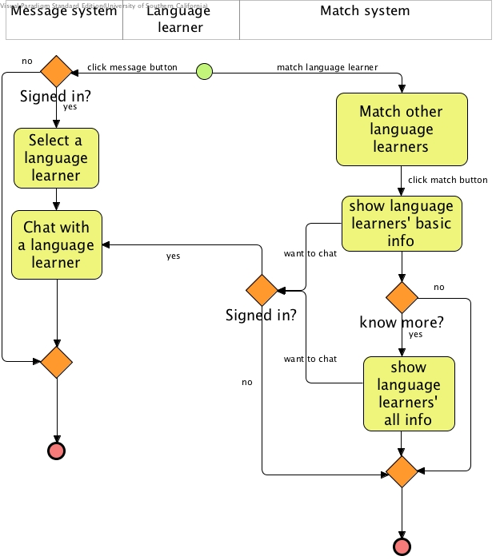

Organizational and Operational Implications

Organizational Transformations
Since we build our system from scratch, so we do not have organizational transformations.

Operational Transformations
Since we build our system from scratch, so we do not have an operational Transformations

